Supplemental materials

We ran a series of simulations following those of Hummel (2011). Specifically, we simulated the similarity of various role-filler pairs using cosine similarity under tensor product binding (TP), synchrony-based binding (SB), and asynchrony-based binding (AB). We ran the simulations using role and filler representations that come from a shared feature space (e.g., word2vec).

Using 12 dimensional vectors, we created a base role and filler, and then created permuted versions of the role and filler to match for similarity 0.5, and similarity 0.0, and similarity -1.0. Figures S1-S3 show the results of using TP, SB, and AB respectively.

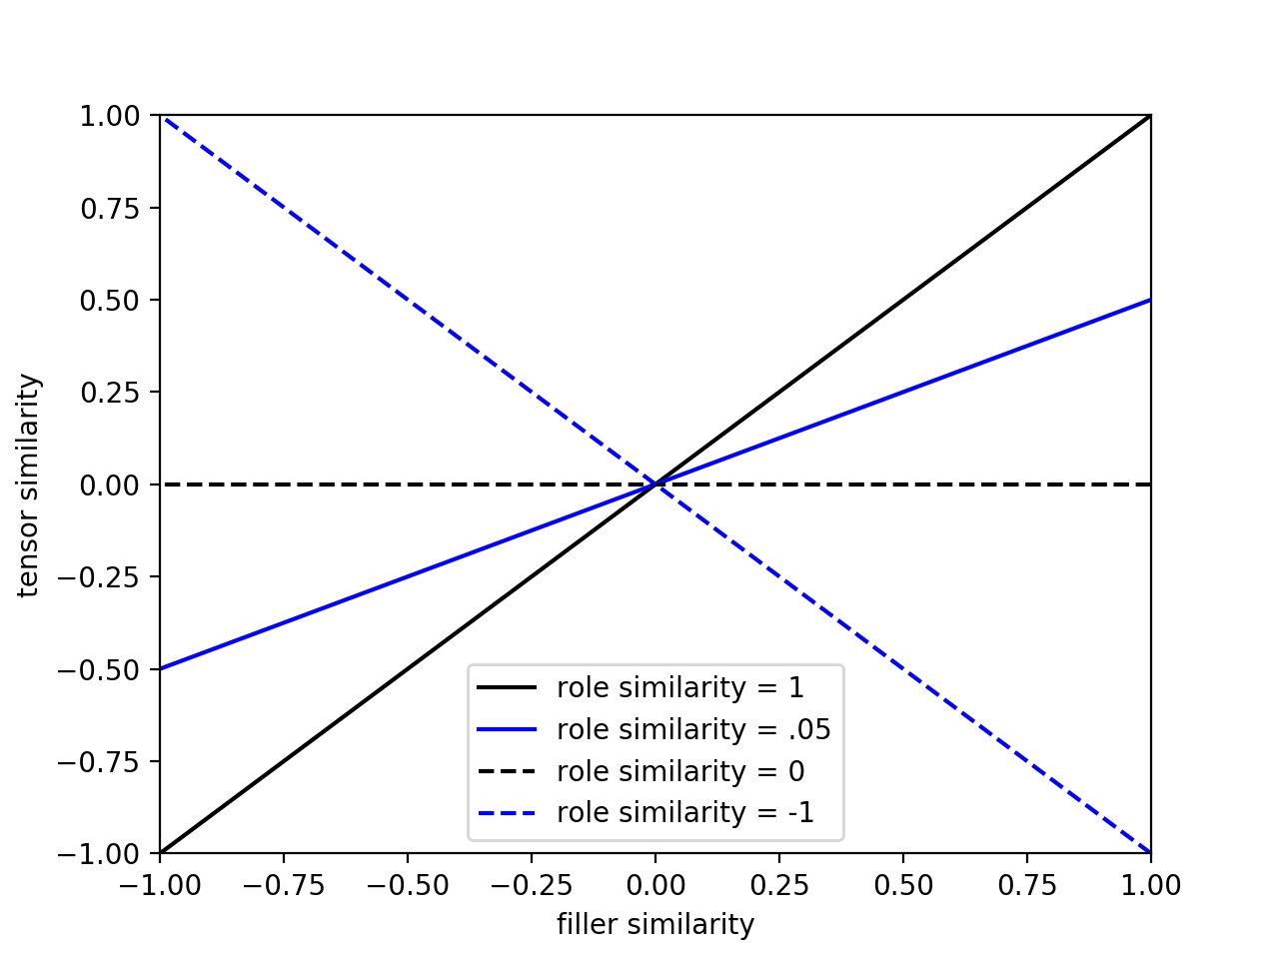Figure S1. Cosine similarity of two role-filler pairs bound by **tensor-product** as a function of role and filler similarity.

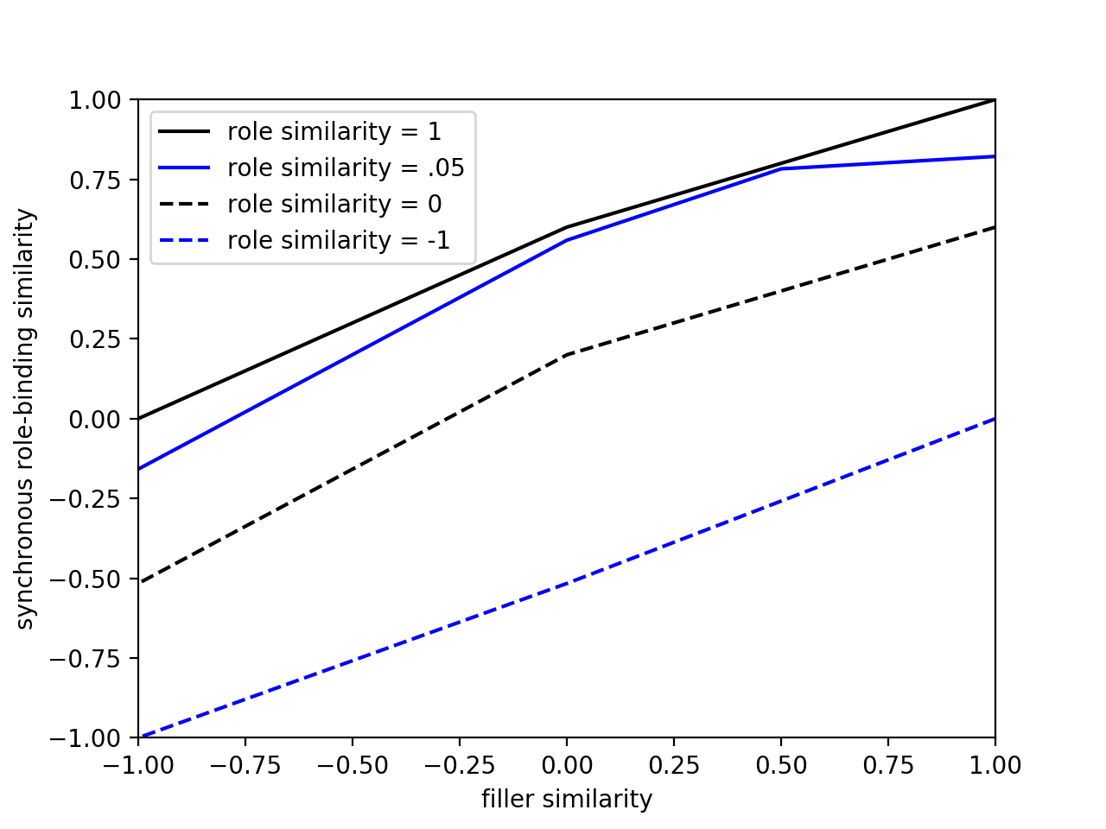

Figure S2. Cosine similarity of two role-filler pairs bound by **synchrony** as a function of role and filler similarity.

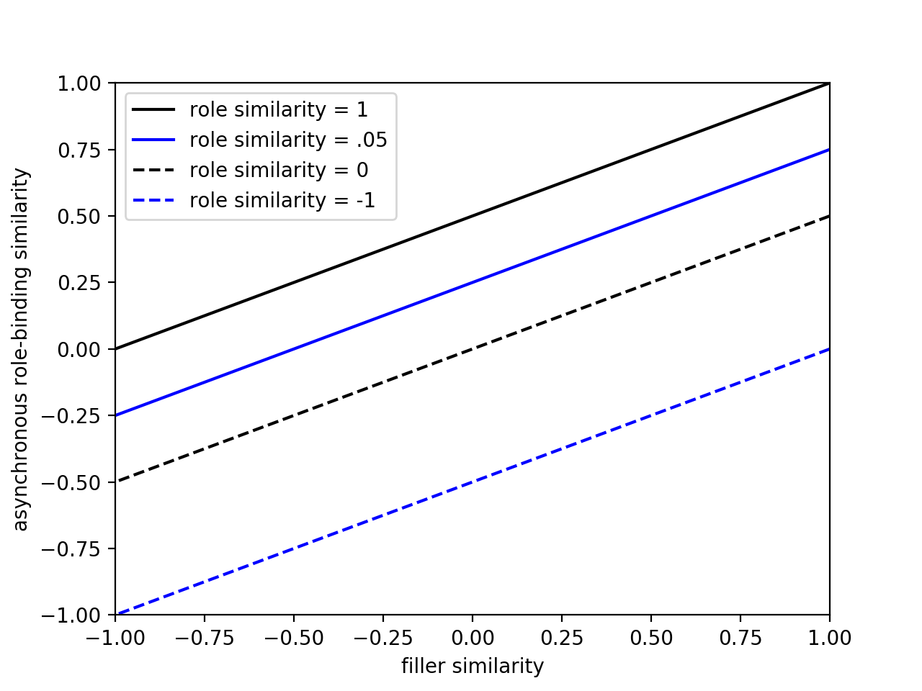

Figure S3. Cosine similarity of two role-filler pairs bound by **asynchrony** as a function of role and filler similarity.

In addition, we ran a simulation using independent dimensions to encode roles and filler. Results for TP and AB were identical, but SB showed a pattern of results identical to those demonstrated by Hummel (2011). When roles and fillers are coded using independent dimensions, SB shows a pattern identical to AB (see Fig. S4).

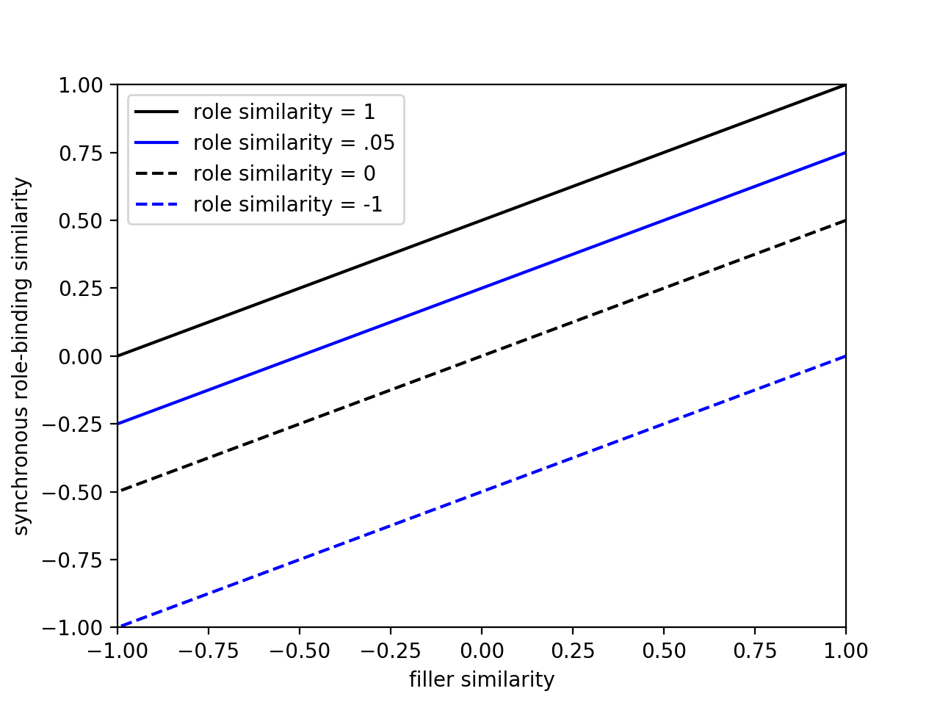

Figure S4. Cosine similarity of two role-filler pairs bound by **synchrony** as a function of role and filler similarity, with roles and fillers coded using independent dimensions.